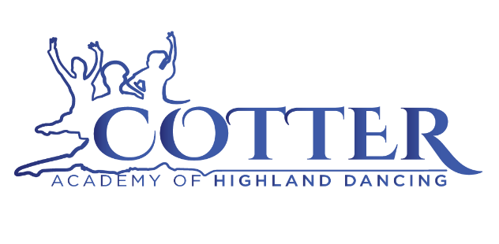

In conjunction with
Brisbane Regional Highland Dancing Association Inc.

Presents
BRISBANE REGIONAL HIGHLAND DANCE TITLES
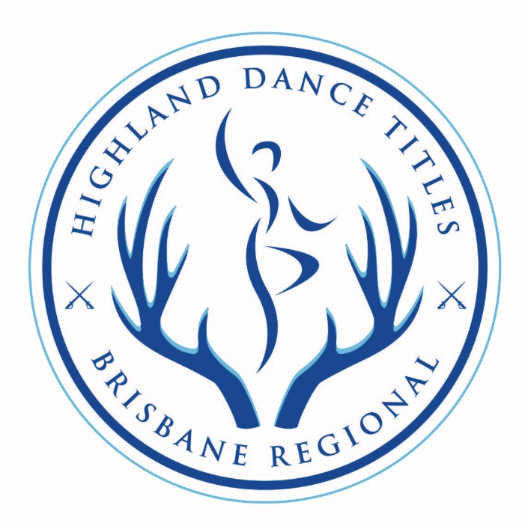
Friday 5th July & Saturday 6th July 2024
Venue: Centenary State High School Performing Arts Centre
1 Moolanda Street, Jindalee Qld 4074.

Adjudicators: Stephanie Dawson (QLD) & Natalie Mearz (Qld)
Entries close 21st June. Late entries accepted until the 1st July with a $10 late fee.
Entries Via HD Comps http://www.hdcomps.com
Enquiries to Amalia Cotter info@cotteracademy.com.au 0407028662
RULES AND CONDITIONS – Friday 5th & SATURDAY 6th July 2024
This Competition is registered with the South Queensland Regional Committee of Highland Dancing Inc. (Reg. No. SQC2024/07 ), and will be conducted under the rules and conditions as set down by RSOBHD and as adopted by ABHDI. To view all RSOBHD/ABHDI rules which will be adhered to, go to: https://sqrchdi.com.au/wp-content/uploads/2023/02/2023_Essential_Competition_Rules.pdf

Other rules :
- PREMIER with RESTRICTION – These dances are restricted to Premier dancers who have not been placed 1st , 2nd or 3rd in a Registered Championship. Titles and section dances will have separate sections for Premier and Premier with Restriction. The Ghillie Callum Cup will be conducted as Premier (Premier with Restriction is eligible to enter).
- TITLES – Dancers may choose not to compete in all dances that make up the Title and still be eligible for an overall title prize, however the full title fees still apply.
- GHILLIE CALLUM CUP- will be conducted in the form of a “Dance off”. It is open to all Premier and Premier with Restriction dancers. The top 1-3 dancers from each age group will qualify to be a finalist to determine the overall winner. An overall winner will be awarded. The highest placed Premier with Restriction dancer will also be awarded.
- AGE GROUPS to be determined upon receipt of entries.
- ENTRY FEES (excluding admin fees) are fully refundable prior to 5th July. After this time, refunds (excluding admin fees) will only be given on production of a medical certificate and if the Competition Secretary is advised in writing prior to the event. No refunds will be given if a dancer does not meet the criteria above or does not compete on the day.
CHOREOGRAPHY RULES
- TEAMS should consist of one school only or more than one school, in which case, the teacher/choreographer must abide by the three month teaching/judging rule. Team may consist of dancers from various classifications.
- CONTENT should consist primarily of movements from Highland, National, Hornpipe and Jig books.
- TIME LIMIT- A maximum time limit applies as follows.
  - Large group (6 + dancers)- 4 minutes
  - Small Group (3-5 dancers)- 3 minutes
  - Due (2 dancers)- 3 minutes
  - Solo (1 Dancer)- 2 minutes
- PROPS may be used during performance, either static or non-static, but live animals are not permitted. Entrance and exit of competitors and the setting up/removal of props is included in the time limit.
- MUSIC may be live or pre-recorded and may include vocal or percussion selections, but in ALL cases must be PREDONIMANTLY Scottish or Celtic in style. Music must be provided to info@cotteracademy.com.au by the 16th of July.
- COSTUMES must follow theme and content of the item.
- JUDGES must be from the current RSOBHD, ABHDI, OBHDA(SA) Judges panel. The number of judges must be 1 or 3 to comply with the current scrutineering system. A total mark should be awarded. No separate prizes for costumes etc.
- ENTRIES must be accompanied by entry fees and late entries will be accepted. Entries received after closing date may not appear in the program.
- AGE GROUPS to be determined upon receipt of entries.
- STAGE DIMENSIONS- 14m x 7m
FRIDAY 5th JULY 2024
Commencing 6pm - Brisbane Regional Highland Dance Choreography Showcase
Entries close 21st June.

All Music to be sent to info@cotteracademy.com.au by 28th June

All Choreography entries via google forms https://forms.gle/BkChUTbP4p77RyWs9

Large group (6 + dancers)- 4 minutes
- Small Group (3-5 dancers)- 3 minutes
- Due (2 dancers)- 3 minutes
- Solo (1 Dancer)- 2 minutes

Age Groups to be determined upon receipt of entries

- Solo- $7.00
- Duo- $15.00
- Small Group- $20.00
- Large Group- $35.00

Payment Details
BSB: 484799
Account Number: 121635638
Please use dancers name as reference (eg. J. Smith)

Entries close 21st June SATURDAY 6th JULY 2024
Session 1- Commencing 9am dressed in Aboyne (Beginners & Novice)
Primary | Pas De Basques
 | Pas De Basques & High cuts
 | Highland Fling | 4 steps
 | Sword Dance | 2 & 1
Beginners or Novice
Title | Highland Fling | 4 steps
 | Sword Dance | 2 & 1
 | Scottish Lilt | 4 steps
Trophy Dance | Highland Fling | 4 steps
Section Dance | Flora MacDonald's Fancy | 4 steps
 | Strathspey & Highland Reel | 2 & 2
Session 2- Commencing approximately 1pm dressed in Hornpipe
Intermediate
Title | Flora MacDonald's Fancy | 4 steps
 | Scottish Lilt | 4 steps
 | Seann Triubhas | 3 & 1
Trophy Dance | Sailors’ Hornpipe | 4 steps
Section Dance | Half Tulloch | 4 parts
 | Barracks Johnnie | 4 steps
 | Highland Fling | 4 steps
Premier OR Premier with Restriction *
Title | Flora MacDonald's Fancy | 4 steps
 | Blue Bonnets | 4 steps
 | Seann Triubhas | 3 & 1
Ghillie Callum Cup | Sword Dance | 2 & 1
Section Dance | Half Tulloch | 4 parts
 | Barracks Johnnie | 4 steps
 | Sailors’ Hornpipe | 4 steps
*Titles and section dances will have separate sections for Premier and Premier with Restriction. The Ghillie Callum Cup will be conducted as a Premier section (Premier with Restriction is eligible to enter).

- Title- $20.00
- Section Dance- $6.00
- Trophy Dance- $12.00
- Ghillie Callum Cup $15.00

Entries Via HD Comps http://www.hdcomps.com

ORDER OF EVENTS- SATURDAY 6th JULY 2024

Dance | Classification
Session 1 commencing 9am
Flora MacDonald's Fancy | Beginners (Section), Novice (Section)
PDB | Primary
Scottish Lilt | Beginners (Title), Novice (Title)
PDB & High cuts | Primary
Highland Fling | Beginners (Title), Novice (Title), Primary
Sword Dance | Beginners (Title), Novice (Title), Primary
Highland Fling (Trophy Dance) | Beginners (Trophy), Novice (Trophy)
Strathspey & Highland Reel | Beginners (Section), Novice (Section)
Presentations
Lunch Break
Session 2 commencing approx. 1pm
Sailors’ Hornpipe | Intermediate (Trophy), Restricted Premier & Premier (Section)
Scottish Lilt | Intermediate (Title)
Blue Bonnets | Restricted Premier & Premier (Title)
Flora MacDonald's Fancy | Intermediate (Title), Restricted Premier & Premier (Title)
Highland Fling | Intermediate (Section)
Sword Dance- Ghillie Callum Cup | All Premier categories(Heats)
Seann Triubhas | Intermediate (Title), Restricted Premier & Premier (Title)
Half Tulloch | Intermediate (Section), Restricted Premier & Premier (Section)
Sword Dance- Ghillie Callum Cup | All Premier categories (Finals)
Barracks Johnnie | Intermediate (Section), Restricted Premier & Premier (Section)
Presentations

